**Year 12 Human Biology**

**Unit 4: Test – Human Evolution (5%)**

**TASK 11 – Test 5**

**Hominid Evolutionary Trends**

**Time: 55 mins**

Multiple Choice: 10 marks

Short Answer: 32 marks

Extended Answer: 12 marks

TOTAL 54 MARKS

**Write your answers on the multiple choice sheet**

**Do not turn page until instructed to do so**

Questions 1 & 2 refer to the picture shown below.

**Section A: Multiple Choice (10 Marks)**

Answer all questions by placing an X through the most correct answer on the multiple choice answer sheet.

1. As a primate, the orang-utan shares a number of features with humans, although there are differences due to the DNA nucleotide sequences in each species. Which of the following is true?
2. Humans have more mobile digits than orang-utans.
3. Orang-utans have a smaller nuchal crest than humans.
4. Orang-utans are specialised for bipedal locomotion.



1. The cerebral cortex of humans is smaller than that of the orang-utan.
2. As a Great Ape, the orang-utan:
3. has a medial condyle that is more robust than their lateral condyle.
4. has an anterior foramen magnum.
5. has two arches in each foot and an opposable big toe.
6. has a pelvis that is short and broad.
7. Which of the following correctly matches the hominid to the associated lifestyle change?
8. Homo habilis – food sharing, Homo erectus – cave murals
9. Homo habilis – controlled use of fire, Homo sapiens – cooperative hunting
10. Homo neanderthalensis – development of agriculture, Australopithecines – home bases
11. Homo habilis – food sharing, Homo erectus – cooperative hunting
12. Compared to Homo erectus, the Neanderthals had a:
13. prominent brow ridge.
14. prognathic face.
15. larger brain size.
16. shorter sagittal crest.
17. With which of the hominids is the use and control of fire associated?
18. Homo sapiens
19. Homo habilis
20. Homo neanderthalensis
21. Homo erectus
22. A fossilised skeleton was discovered in a semi-arboreal region of Africa. Paleoanthropologists determined that the skeleton is bipedal due to several distinguishing features. What features would you expect to be present in this skeleton?

1. Narrow pelvis, s-shaped spine, protruding jaw
2. Central foramen magnum, protruding jaw, short pelvis
3. S-shaped spine, long pelvis, central foramen magnum
4. Broad pelvis, central foramen magnum, s-shaped spine

1. The following list refers to hominid physical characteristics:
2. Small brain size relative to body size.
3. Dental diastema.
4. Centrally placed foramen magnum.
5. S-Shaped vertebrae curve.
6. Transverse arch in the foot.
7. Prominent brow ridges

Which characteristics would you expect to find in a fossilised pongid (ape)?

1. 1, 2 and 6
2. 1, 5 and 6
3. 2, 4 and 6
4. 1, 4 and 6

Questions 8 and 9 refer to the diagram below of hominid lower limbs.

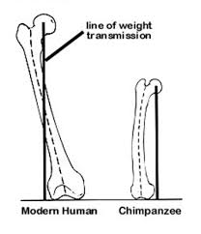

**A B**

1. The femur of hominid A has a greater carrying angle than hominid B. This is because hominid A is
   1. human and the carrying angle allows it to have a wider pelvis than an ape, to assist in childbirth.
   2. an ape and the carrying angle increases the length of the femur to allow for quadrupedal walking.
   3. an ape and the carrying angle allows the knee to bend and straighten for bipedal walking.
   4. human and the carrying angle places the foot under the centre of gravity for a striding gait.
2. The foot of hominid A would have
   1. a larger calcaneus (heel bone) than hominid B.
   2. a longitudinal arch that is lacking in hominid B.
   3. greater opposability of the big toe than hominid B.
   4. a more flexible ankle joint than hominid B.
3. Humans have opposable thumbs. Opposable thumbs allow humans to:
4. grasp objects.
5. write with a pen.
6. touch the wrist of the same hand.
7. touch the tip of fingers with the thumb on same hand.

**End of Section A**

**Year 12 Human Biology**

**Unit 4: Test – Human Evolution (5%)**

Name _________________________________________

Teacher Mrs Cunningham

**TASK 11 – Test 5 - Hominid Evolutionary Trends**

TOTAL / 54 MARKS

**Multiple choice & answer booklet**

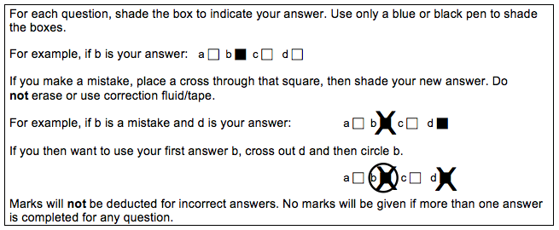

|  |  |
| --- | --- |
| **1** | a ⬜ b ⬜ c ⬜ d ⬜ |
| **2** | a ⬜ b ⬜ c ⬜ d ⬜ |
| **3** | a ⬜ b ⬜ c ⬜ d ⬜ |
| **4** | a ⬜ b ⬜ c ⬜ d ⬜ |
| **5** | a ⬜ b ⬜ c ⬜ d ⬜ |

|  |  |
| --- | --- |
| **6** | a ⬜ b ⬜ c ⬜ d ⬜ |
| **7** | a ⬜ b ⬜ c ⬜ d ⬜ |
| **8** | a ⬜ b ⬜ c ⬜ d ⬜ |
| **9** | a ⬜ b ⬜ c ⬜ d ⬜ |
| **10** | a ⬜ b ⬜ c ⬜ d ⬜ |

**Section B: Short Answer (32 Marks)**

Answer all questions in the spaces provided.

**Question 13 (4 marks)**

Part (a) of the question refers to the diagram of a primate phylogeny below.

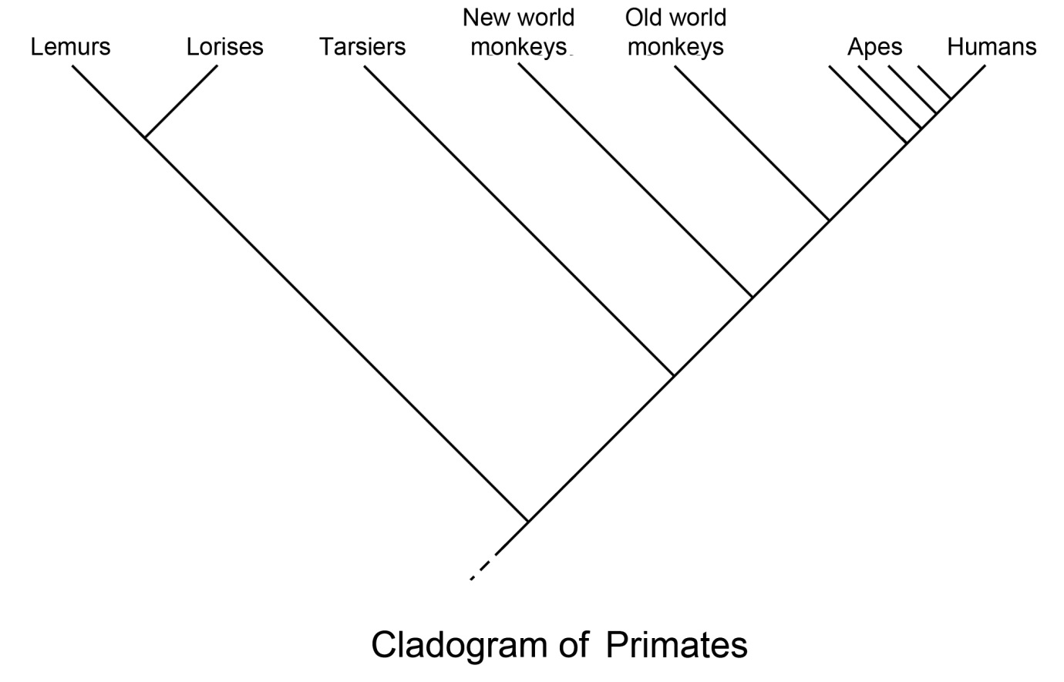

1. According to the phylogenic tree, which primate/s were the first to diverge in evolutionary time? (1 mark)

___________________________________________________________________

1. Complete the table below, describing the evolutionary trends (how the characteristic has evolved) that occur within Hominids. (3 marks)

|  |  |
| --- | --- |
| **Characteristic** | **Evolutionary trend** |
| Mobility of digits of the hand |  |
| Dental arcade |  |
| Diastema |  |

**Question 14 (7 marks)**

Part (a) and (b) of the question refers to the diagram of the Hominid specimenskull below.

1. Name the hominin specimen below. (1 mark)

**___________________________________________________________________**

1. For each of the parts identified in the diagram of the skull, describe how the skull of *Homo habilis* differs from that shown in the diagram and give one (1) advantage for *Homo habilis* for each change. (6 marks)

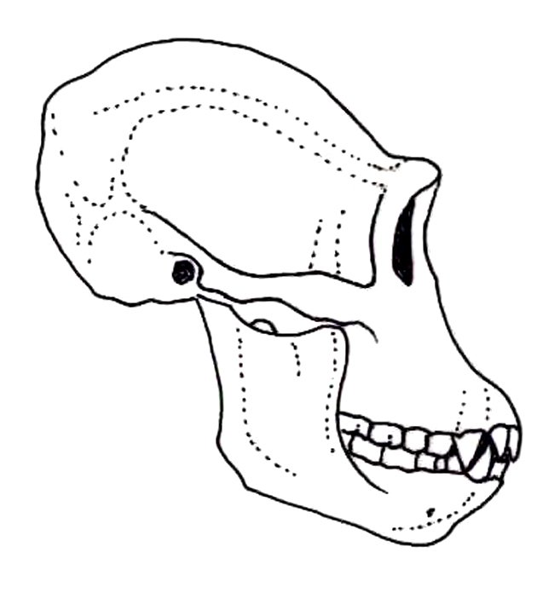

**X**

**Z**

**Y**

|  |  |  |
| --- | --- | --- |
|  | **How the skull of a typical modern *Homo habilis* differs to the diagram** | **Advantage** |
| **X** |  |  |
| **Y** |  |  |
| **Z** |  |  |

**Question 15 (6 Marks)**

Part (a) of the question refers to the tool diagrams A, B, C and D shown below.

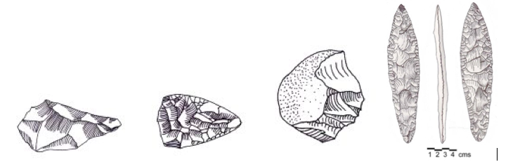 **A B C D**

1. Identify which tool (A, B, C or D) is the youngest. (1 mark)

___________________________________________________________________

1. Name the hominin specimen which is associated with tool C. (1 mark)

___________________________________________________________________

1. Name the tool culture for tool A and describe one (1) cranial feature of the hominin associated with these tools. (2 marks)

___________________________________________________________________

___________________________________________________________________

___________________________________________________________________

1. Describe the difference in workmanship between tools B and D. (2 marks)

___________________________________________________________________

___________________________________________________________________

___________________________________________________________________

___________________________________________________________________

**Question 16 (4 marks)**

The table below give information on cranial capacity, height and mass of our early human ancestors up to modern day humans. (*All data is approximate*)

|  |  |  |  |
| --- | --- | --- | --- |
| **Species** | **Cranial capacity (cm3)** | **Height (m)** | **Mass (kg)** |
| *Australopithicus afarensis* | 430 | 1.2 | 30 |
| *Australopithicus africanus* | 460 | 1.3 | 35 |
| *Paranthropus robustus* | 540 | 1.5 | 65 |
| *Homo habilis* | 600 | 1.3 | 45 |
| *Homo erectus* | 1050 | 1.7 | 60 |
| *Homo neanderthalensis* | 1485 | 1.6 | 70 |
| *Homo sapiens* | 1350 | 1.9 | 75 |

(a) What conclusion can be drawn from the data given on cranial capacity? (2 marks)

______________________________________________________________________________

______________________________________________________________________________

______________________________________________________________________________

(b) Using only the height and mass data of *Homo neanderthalensis* and *Homo sapiens,* give a possible explanation for this difference in build. (2 marks)

______________________________________________________________________________

______________________________________________________________________________

______________________________________________________________________________

**Question 17 (11 marks)**

Archaeologists are studying evidence collected from a fossil dig. They believe the fossil remains belong to *Homo neanderthalensis* and have dated the age of the site at approximately 100, 000 years. The archaeologists are searching for more evidence to support their theory.

1. Identify two(2) pieces of evidence, not including the skeletal remains, that archaeologists might find at the site. For each, propose the cultural behaviour associated with *Homo neanderthalensis* that the evidence suggests. (4 marks)

|  |  |
| --- | --- |
| **Archaeological evidence** | **Cultural behaviour** |
|  |  |
|  |  |

1. Suggest two (2) possible explanations for the extinction of *Homo neanderthalensis*.

(2 marks)

______________________________________________________________________________

______________________________________________________________________________

______________________________________________________________________________

______________________________________________________________________________

______________________________________________________________________________

1. Explain three (3) possible reasons why humans changed from a hunter-gatherer lifestyle to an agricultural one. (3 marks)

______________________________________________________________________________

______________________________________________________________________________

______________________________________________________________________________

______________________________________________________________________________

______________________________________________________________________________

A footprint was found at an alternative site and on the basis of tools also found there, the archaeologists concluded the footprint belonged to *Homo sapiens* approximately 13,000 years old.

1. Identify a tool culture that could provide support for the fossilised footprint to belong to *Homo sapiens* and outline (1) feature specific to these tools. (2 marks)

______________________________________________________________________________

______________________________________________________________________________

______________________________________________________________________________

______________________________________________________________________________

______________________________________________________________________________

**End of Section B**

**Section C: Extended Answer (12 Marks)**

Answer the question below in the space provided

**Question 18**

When first discovered, scientists believed that the Australopithecines were bipedal and walked with a striding gait.

a) Explain two (2) selection pressures (advantages) that may have led to the development of bipedalism in early hominins. (4 marks)

b) Describe four (4) pieces of fossil evidence from the knee upwards that would supports the belief they were bipedal and for each, explain the advantage to bipedalism that it provides. (8 marks)

______________________________________________________________________________

______________________________________________________________________________

______________________________________________________________________________

______________________________________________________________________________

______________________________________________________________________________

______________________________________________________________________________

______________________________________________________________________________

______________________________________________________________________________

______________________________________________________________________________

______________________________________________________________________________

______________________________________________________________________________

______________________________________________________________________________

______________________________________________________________________________

______________________________________________________________________________

______________________________________________________________________________

______________________________________________________________________________

______________________________________________________________________________

______________________________________________________________________________

______________________________________________________________________________

______________________________________________________________________________

______________________________________________________________________________

______________________________________________________________________________

______________________________________________________________________________

______________________________________________________________________________

______________________________________________________________________________

______________________________________________________________________________

______________________________________________________________________________

______________________________________________________________________________

______________________________________________________________________________

______________________________________________________________________________

______________________________________________________________________________

______________________________________________________________________________

______________________________________________________________________________

______________________________________________________________________________

______________________________________________________________________________

______________________________________________________________________________

______________________________________________________________________________

______________________________________________________________________________

______________________________________________________________________________

______________________________________________________________________________

______________________________________________________________________________

______________________________________________________________________________

______________________________________________________________________________

______________________________________________________________________________

______________________________________________________________________________

______________________________________________________________________________

______________________________________________________________________________

______________________________________________________________________________

______________________________________________________________________________

______________________________________________________________________________

______________________________________________________________________________

______________________________________________________________________________

______________________________________________________________________________

______________________________________________________________________________

______________________________________________________________________________

______________________________________________________________________________

______________________________________________________________________________

______________________________________________________________________________

______________________________________________________________________________

______________________________________________________________________________

______________________________________________________________________________

______________________________________________________________________________

______________________________________________________________________________

______________________________________________________________________________

______________________________________________________________________________

______________________________________________________________________________

______________________________________________________________________________

______________________________________________________________________________

______________________________________________________________________________

______________________________________________________________________________

______________________________________________________________________________

______________________________________________________________________________

______________________________________________________________________________

______________________________________________________________________________

______________________________________________________________________________

______________________________________________________________________________

______________________________________________________________________________

______________________________________________________________________________

______________________________________________________________________________